Kevin Hinton & Taft Sandbakken

CS 470

Dr. Seppi

Kalman Filter Lab

|  |  |  |  |
| --- | --- | --- | --- |
| Number | Predicted | Observed | Estimated |
| 1 | 3.31363168,-193.73431803 | -16.3227438443,-191.181690097 | -9.68106482,-192.29849444 |
| 2 | -138.89068221,-145.8468932 | -147.978436566,-151.398195513 | -144.90734768,-148.98379794 |
| 3 | -274.84767578,-99.02634045 | -275.262775248,-92.9185647859 | -275.12249919,-95.57486552 |
| 4 | -396.14653859,-62.81765516 | -388.417077985,-53.628113967 | -391.02912236,-57.62468882 |
| 5 | -383.73300829, -1.36579862 | -394.855760659,-13.6569969089 | -391.09700902,-8.31149677 |
| 6 | -394.04320608, 22.98024295 | -393.908577651,26.8088487135 | -393.95407312, 25.14377 |
| 7 | -396.60886847, 86.60572006 | -392.844902069,87.3022449332 | -394.11687275, 86.99932298 |
| 8 | -391.7919705, 131.53843463 | -386.25711344,124.274625459 | -388.12752756, 127.43369035 |
| 9 | -395.12286038, 166.93590309 | -401.403370019,165.272326281 | -399.28097485, 165.99582369 |
| 10 | -394.44348841, 222.66792001 | -402.433945251,215.731369725 | -399.73370148, 218.74810818 |

Sitting Duck Pigeon

Estimated at: -3.064017 , -200.91497428

Predicted at: -5.62917802, -206.55446646

Observed at: -2.42353735591,-199.506883349

E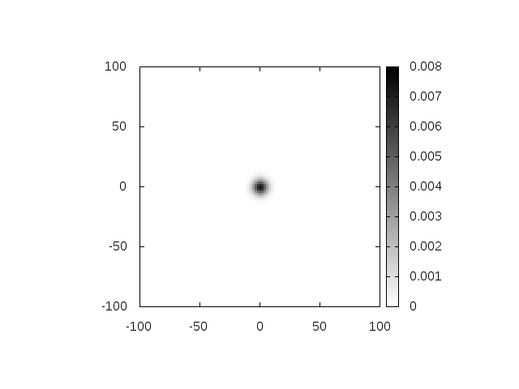stimated at: 4.83744445, -196.0030473

Predicted at: -3.06325643, -200.91330217

Observed at: 14.5495617181,-189.929675033

Estimated at: 1.53247042, -196.4462741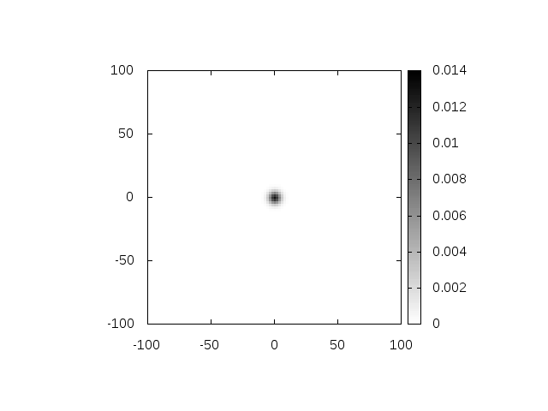

Predicted at: 5.05146045, -195.95899275

Observed at: -4.94125821456,-197.470462834

Conforming Pigeon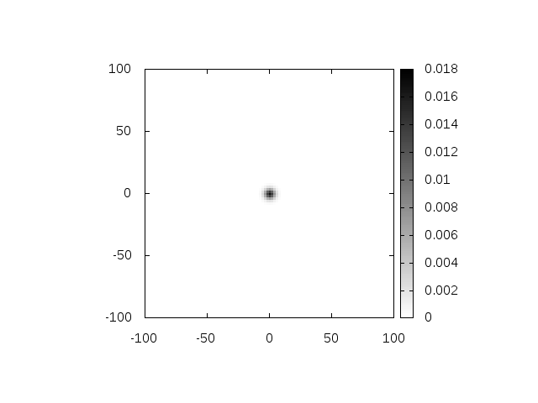

Enemy 0 at: -98.75819852, -157.20667559

Predicted at: 4.57405536, -200.22520134

Observed at: -124.558608348,-146.465638282



Estimated at: -122.50187372, -146.60210899

Predicted at: -98.78883651, -157.19392061

Observed at: -151.65166707,-133.501360321



Estimated at: -133.74497471, -140.24625452

Predicted at: -123.1755579, -146.49696873

Observed at: -153.18905828,-127.10823673

Wild Pigeon

Estimated at: -202.73728083, -128.67183231

Predicted at: -198.54656361, -121.26652663

Observed at: -208.354348221,-146.2509024

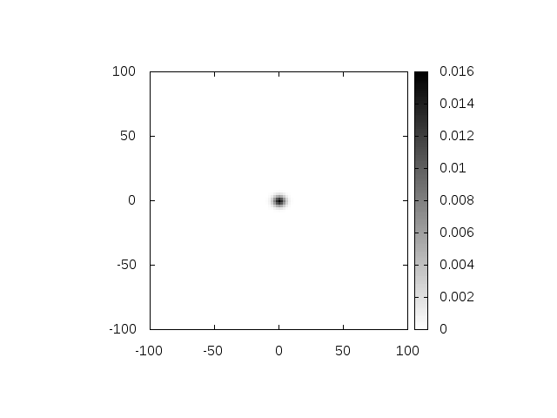

Estimated at: -208.53594457, -139.87637433

Predicted at: -211.78954118, -131.04113625

Observed at: -206.104548167,-155.868546033

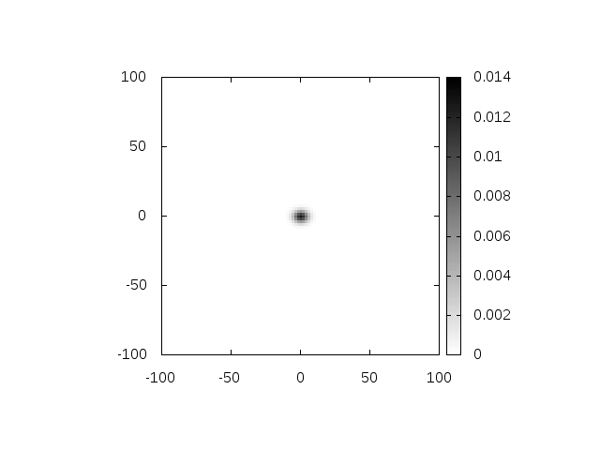

Estimated at: -202.36292563, -151.60274775

Predicted at: -218.13978218, -146.78662007

Observed at: -193.59703862,-157.363117556

